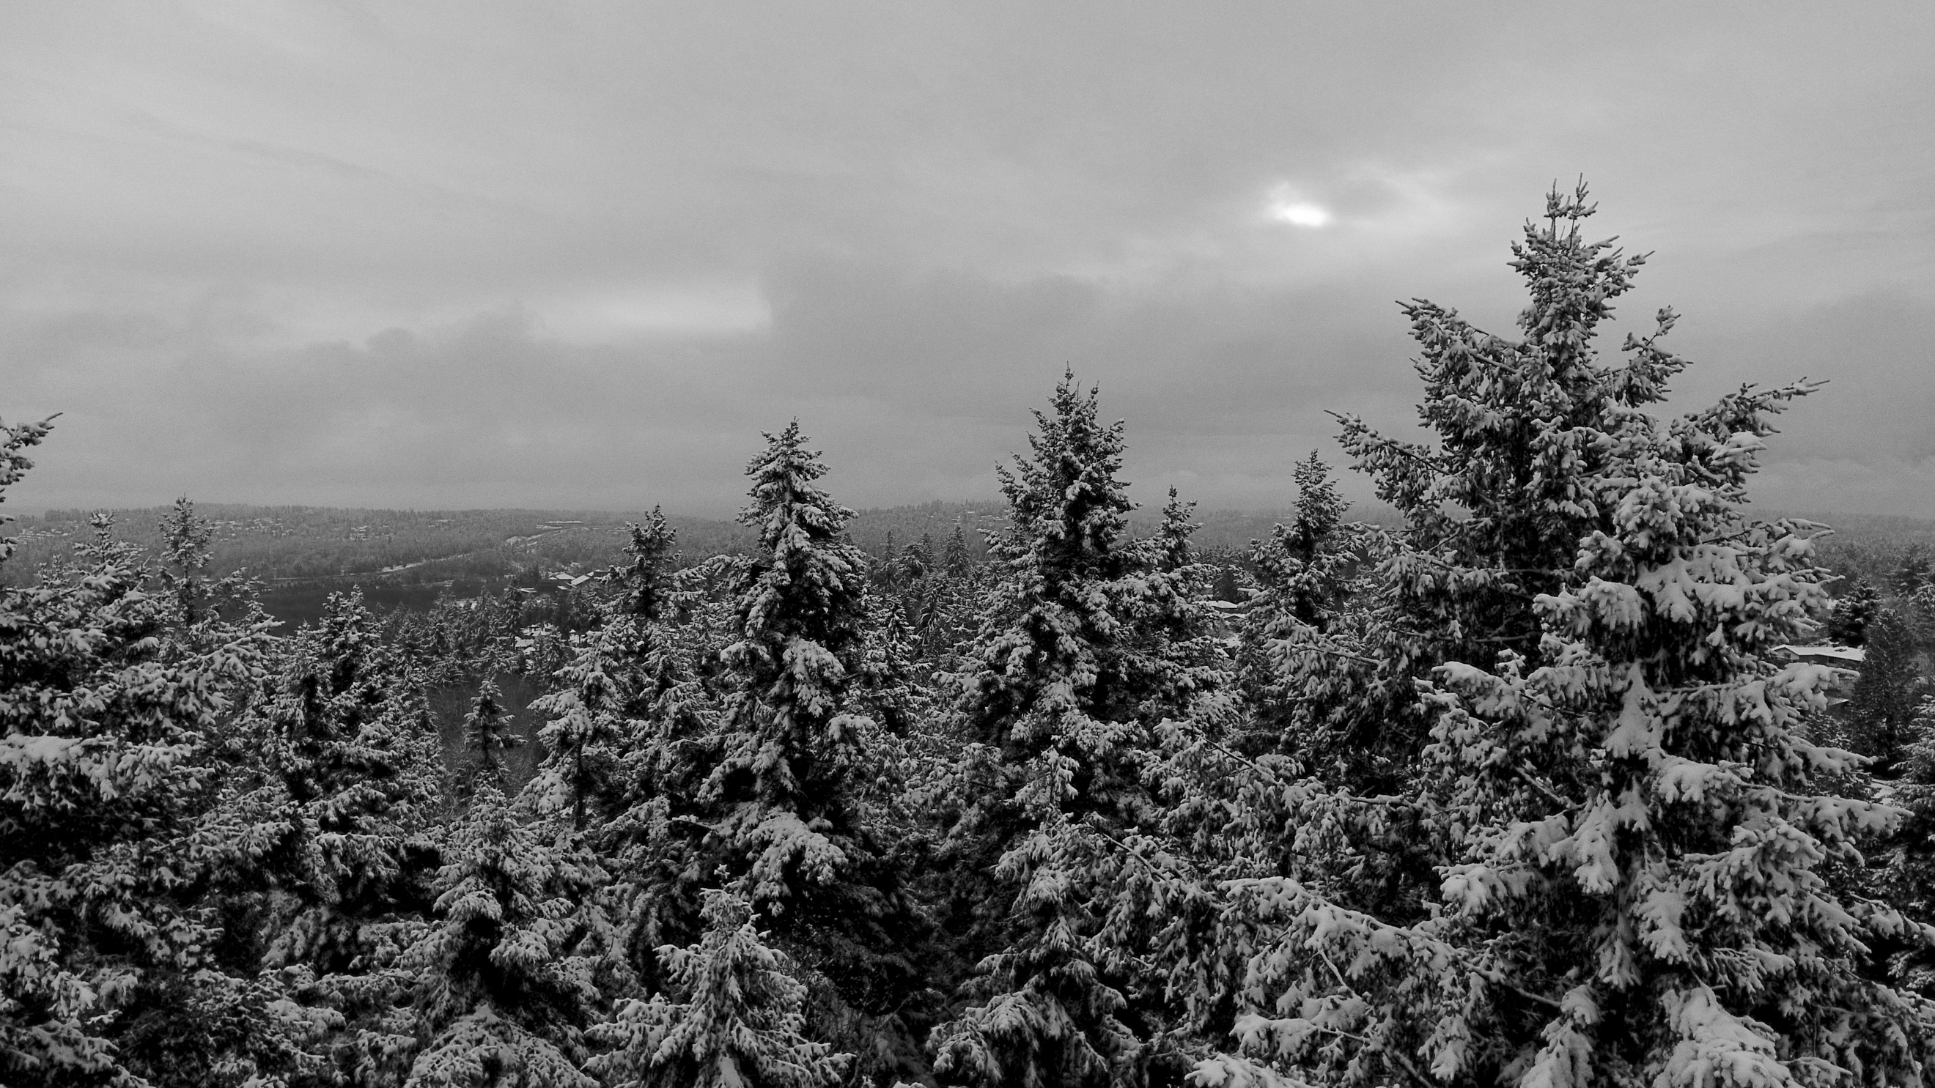
GSR SCHOOL

Finding our way through AA’s vast landscape of service.
It is always wise to have a compass.
District 39 is hosting GSR School at a location convenient to all eastside districts. Please bring a snack to share and join us.

Facilitated by Western Washington Servants: Alan F., Alt Delegate and Courtney S., Archives Chair

Saturday, January 27
9:00 AM - 12 PM
Grace Lutheran Church
9625 NE 8th Street
Bellevue 98004
Pearson Hall (south building)

…………………………………………………………………………………………………………………………………………………....

GSR SCHOOL

Finding our way through AA’s vast landscape of service.
It is always wise to have a compass.
District 39 is hosting GSR School at a location convenient to all eastside districts. Please bring a snack to share and join us.

Facilitated by Western Washington Servants: Alan F., Alt Delegate and Courtney S., Archives Chair

Saturday, January 27
9:00 AM - 12 PM
Grace Lutheran Church
9625 NE 8th Street
Bellevue 98004
Pearson Hall (south building)

