The Captain's Table

Closed AA Study Group

Sunset Community Church 1032 Edmonds Ave NE Renton 98056

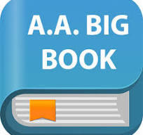

It starts Tuesday, April 22nd, 2025, and then every Tuesday thereafter at 7pm to 8pm.

All you need is your own AA Big Book, #2 pencils, and one or some, Highlighters, and a sense of humor as we want this to be a good experience. We will do our best, to not be a (lot of glum)
(#2 optional pencils, it could be a #3 pencil, pen, mechanical pencil, crayon etc.)

Be your own Captain

